
Amazon Interview Worksheet
HAVE BACKBONE; DISAGREE AND COMMIT
Definition and Indicators
Have Backbone; Disagree and Commit: Leaders are obligated to respectfully challenge decisions when they disagree, even when doing so is uncomfortable or exhausting. Leaders have conviction and are tenacious. They do not compromise for the sake of social cohesion. Once a decision is determined, they commit wholly.
What this looks like in Practice
As a people manager do you… | As an individual contributor do you…
- Question rigorously, challenge assumptions and escalate issues up and across the “food chain” when you’re not satisfied, even if unpopular?
- Stand up for what you believe is in the best interest of the company and our customers?
- Openly demonstrate your support and commitment to decisions that have been made, even though you may not have originally agreed? Refrain from being transparent with these types of decisions in the best interests of your employees? | - Get on board with decisions that have been made, even though you may not have originally agreed?

Have a Backbone; Disagree and Commit - Suggested Behavioral Interview Questions
For each question you choose, use a separate STAR Worksheet
Questions for (Manager) in parentheses

- Tell me about a time that you strongly disagreed with your manager on something you deemed to be very important to the business. What was it about and how did you handle it?
- Give me an example of when you took an unpopular stance in a meeting with peers and your leader and you were the outlier. What was it, why did you feel strongly about it, and what did you do?
- When do you decide to go along with the group decision even if you disagree? Give me an example of a time you chose to acquiesce to the group even when you disagreed. Would you make the same decision now?
- Describe a time where you felt really strongly about something but ultimately lost the argument. How hard did you press the issue? What was your approach after you lost the argument?
- Give an example when you submitted a good idea to your manager and he/she did not take action on it? How did you handle it? What was the end outcome?
- Tell me about a time the business gained something because you persisted for a length of time. Why were you so determined? How did it turn out?
- Provide an example of a time when you have had to make a difficult decision under pressure and then defend and justify it. Was it the right decision?
- Give an example of when you had to support a business initiative with which you didn’t necessarily agree. How did you handle it? (Manager)
- Tell me about a time when you pushed back against a decision that negatively impacted your team. What was the issue and how did it turn out? (Manager)

STAR WORKSHEET
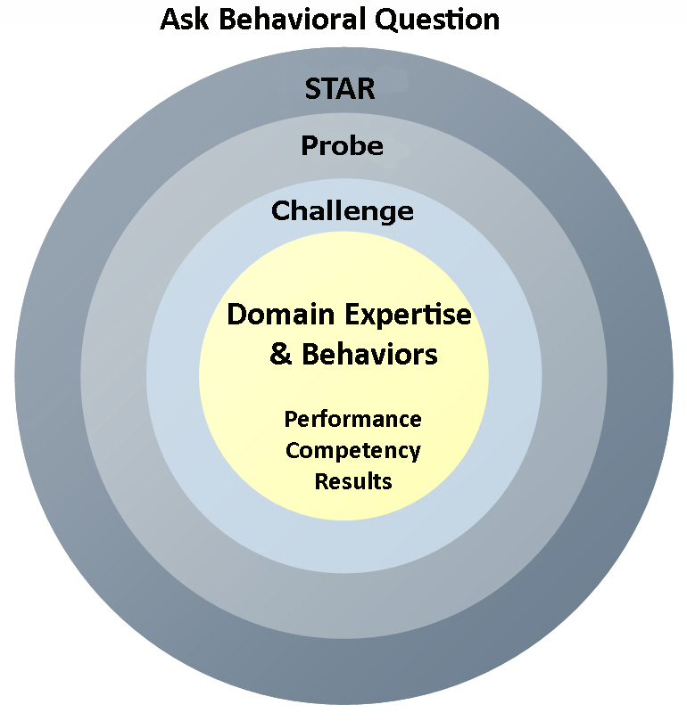
Your Behavioral Question:___________________________________________________________________Leadership Principle:_________________

- Choose behavioral question that provoke specific examples or stories for your assigned Leadership Principle(s).
- Process the example using STAR. Stories have beginnings (Situation/Task), middles (Actions) and ends (Results).
- Once you have established the story, PROBE to dive deeper on your assigned competency (Leadership Principle), get clarity or pursue a concern.
- If appropriate, CHALLENGE the candidate’s statements, decisions or thought process.
S  T | SITUATION/TASK - Describe the situation/task you faced and the context of the story  Answers the questions: where did this occur, when did it happen, why is it important?  Probing Questions:  - Why is this important? What was the goal?  - What was the initial scope of the project? What were the challenges?  - What were the risks and potential consequences if nothing happened?  Challenge Questions:  - Why did you choose this story to illustrate a xyz accomplishment?  - What other stories can you think of that demonstrate.. xyz?  - Could you come up with an example that is more recent? | Notes
A | ACTION - What actions did you take?  Answers the questions: what did you personally own, how did you do it, who else was involved?  Probing Questions:  - Deep probe functional expertise and/or assigned core competency.  - Were you the key driver or project owner?  - What was your biggest contribution? What unique value did you bring?  - What were the most significant obstacles you faced? How did you overcome them?  Challenge Questions:  - What did you do specifically versus the team?  - How did you set priorities…deal with xyz problem… or get manager buy-in?  - What decisions did you challenge? Why? How did you influence the right outcome?
R | RESULTS - How did you measure success for this project? What results did you achieve?  $ Cost savings, revenue generation  # Quantify to understand volume, size, scale  % Percentage change, year over year improvements  Time to market, implementation time, time savings  Impact on the customer, the team  δ Quality improvements  Probing Questions:  - Why did you choose to focus on these results? What other results were important?  - You mentioned revenue, what percentage change is that year over year?  - What trade-offs did you have to make to achieve this? (quality, cost, time)  - I’m concerned about… (the time it took, the volume, the customer impact), tell me more…  Challenge Questions:  - What were the lessons learned? What would you have done differently?  - How would you implement this at Amazon?  - How did these results compare to your actual goals? (refer back to goal stated in Situation)

